

Curve

Numeric 2D library

Version 2.36.0
(Last updated 28-Apr-08)
Contents

1. General information 4
2. Interface 4
3. Functions 5
3.1 Function 1 – 2D Curve calculations 5
3.2 Function 2 – Invert operations 6
3.3 Function 3 – 2D offset (Radius correction) 6
3.4 Function 4 – 2D comparison 7
3.5 Function 5 – Display/print curves 8
3.6 Function 6 – 2D best-fit 8
3.7 Function 7 – Intersection with line 9
3.8 Function 8 – Intersection with circle 10
3.9 * Function 9 – Middle Curve 11
3.10 Function 10 – Circle centering 11
3.11 Function 11 – Line fit 12
3.12 Function 12 – Circle fit 12
3.13 Function 13 – Filter Fourier 13
3.14 Function 14 – Intersection betw. 2 curves 14
3.15 Function 15 – Perimeter, square 14
3.16* Function 16 – Automatic Curve splitting function 15
3.17 Function 17 – Shift Points to given radial position along given profile 16
4. Reporting problems and suggestions 17
5. Licensing 17

* Under development

1. General information

The library curve.exe is a numeric library that performs spline curve calculations on a set of “point” data. The splines constructed are interpolated constrained third order splines (smooth splines). The library is especially designed to be suitable for evaluation of real data sets obtained with instruments or methods that may have high level of uncertainty and due to that reason the data need to be processed accurately, taking into account the possibility to have badly distributed data. The library has as main application filed the curve calculations for use in the dimensional metrology, but can be used for any purpose, where this type of calculation is needed.

The library curve.exe supports set of functions that can perform different type of calculations.

The library does not support graphical user interface for input of the data. It is intended to use it in applications that provide personalized interface to the end user. This document describes briefly the supported interface in order to be able to use the functions of curve.exe.

2. Interface

In order to pass and retrieve the data to curve.exe both “file” and COM interface are available. This document describes the “File” interface as it is easier to debug and to test.

To pass the data and the parameters 2 separate files have to be created (2dinp.dat and 2dpar.dat). Running curve.exe gives out the result in the file 2dout.dat.

So, to use curve.exe:
- prepare 2dinp.dat and 2dpar.dat as you wish
- run curve.exe (it will ook for 2dinp.dat and 2dpar.dat files)
- the result of the calculations will be given in 2dout.dat (except for function 5, where a graphical window will be opened)

Here is the format of 2dinp.dat and 2dout.dat:

$ELE (NAM=Name,TYP=APT, FLD=(X,Y,Z,R,U,V,W,A,D))
xxxx, yyyy, zzzz, rrrr, uuuu, vvvv, wwww, aaaa, dddd
$END

Where:

x,y,z - point coordinates in 3D
u,v,w - normal vector
a - size of normal vector
r – not used
d – not used

Example:
$ELE (NAM=ELE:GANA009A,TYP=APT, FLD=(X,Y,Z,R,U,V,W,A,D))
38.7378, 5.0000, 0.0000, 0.0000, 0.9659, 0.2588, 0.0000, 0.0000, 0.0000
38.6118, 5.4701, 0.0000, 0.0000, 0.9659, 0.2588, 0.0000, 0.0000, 0.0000
38.4858, 5.9401, 0.0000, 0.0000, 0.9659, 0.2588, 0.0000, 0.0000, 0.0000
$END

Minimum of 3 points is required (for line best-fit F11 – 2 points)!

Depending on the function some additional data may be needed or obtained. The details will be given bellow.

3. Functions

Using the file interface, the 2dpar.dat is used to pass the parameters (2dinp.dat passes the point data). Bellow follows the list of the functions and the description of the possible 2dpar.dat configurations in order to recall the corresponding functions.

3.1 Function 1 – 2D Curve calculations

This function can calculate the 2D directions (normal to the curve) for each point given in 2dinp.dat. The function will automatically remove the points, which have the same co-ordinates. Optionally it can remove points that are closer than a certain threshold, or it can generate new points between the given points.

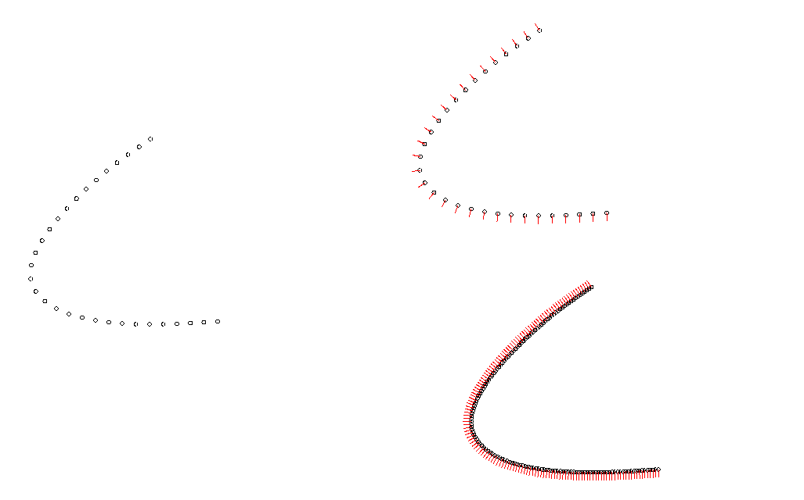
Input points
(without normals)
Output points
(with calculated normals)
Output points
(with intermediate point generation)

Function=1
Parameter | Description | Allowed values | Default
result | Name of the result element | Any String | INPUTNAME
closed | Type of the curve (opened / closed) | Y or N | N
plane | Workplane | XY,YZ or ZX | XY
threshold | Recognize and remove duplicated points. If the distance between 2 points is less or equals the threshold value, then the point is removed. If combined with the sort option, the points will be sorted first | Double | 0
external | parameter used to specify the direction of the radius correction with the normal vectors. The meaning is how the measurement is performed, external or internal to the detail | Y or N | Y
material | parameter used to specify the direction of the radius correction with the normal vectors It is only for not closed curves | L or R | L
intermediate | integer parameter that specifies a number of intermediate points to be created between every 2 consecutive points. This parameter is for both closed and open curves | Integer | 0
minline | parameter that specifies the allowed length between 2 measured points. Intermediate points are created on the straight line connection 2 points where minline is exceed, default 0.0 is off. This parameter is for both closed and open curves | Double | 0
sort | parameter that specifies if the points should be sorted. Default is N. The points are sorted by the distance to the nearest point from the nearest quarter arc only. This parameter is for both closed and open curves | Y or N | N

3.2 Function 2 – Invert operations

This function can invert the point order or the normal direction of a given point sequence.

Function=2
Parameter | Description | Allowed values | Default
Result | Name of the result element | String | INPUTNAME
Plane | Workplane | XY,YZ or ZX | XY
Invertsequence | inverting the order of points | Y or N | N
Invertdirection | inverting the normal vectors | Y or N | N

3.3 Function 3 – 2D offset (Radius correction)

Performs offset operation on a point sequence

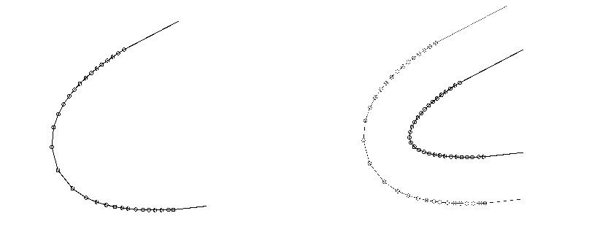
Input Curve
Output Curve

Function=3
Parameter | Description | Allowed values | Default
result | Name of the result element | Any String | INPUTNAME
Closed | Type of the curve (opened / closed) | Y or N | N
Plane | Workplane | XY,YZ or ZX | XY
Radius_corr | radius correction in MM, mandatory parameter | Double | Mandatory!
External | parameter used to specify the direction of the radius correction with the normal vectors. The meaning is how the measurement is performed, external or internal to the detail | Y or N | Y
Material | parameter used to specify the direction of the radius correction with the normal vectors It is only for not closed curves | L or R | L
Sort | parameter that specifies if the points should be sorted. Default is N. The points are sorted by the distance to the nearest point from the nearest quarter arc only. This parameter is for both closed and open curves | Y or N | N

3.4 Function 4 – 2D comparison

This function performs 2D comparison between 2 curves. You must pass in 2dinp.dat 2 curves!

Function=4
Parameter | Description | Allowed values | Default
result | Name of the result element | Any String | INPUTNAME
Closed | Type of the curve (opened / closed) | Y or N | N
Plane | Workplane | XY,YZ or ZX | XY
External | parameter used to specify the direction of the radius correction with the normal vectors. The meaning is how the measurement is performed, external or internal to the detail | Y or N | Y
Material | parameter used to specify the direction of the radius correction with the normal vectors It is only for not closed curves | L or R | L
Sort | parameter that specifies if the points should be sorted. Default is N. The points are sorted by the distance to the nearest point from the nearest quarter arc only. This parameter is for both closed and open curves | Y or N | N
EvaluationPlace | Defines the evaluation place (which points are the reference for the deviation calculation). The possible inputs are 1 or 2, which is first or second curve as given in 2dinp.dat. See the pictures bellow. 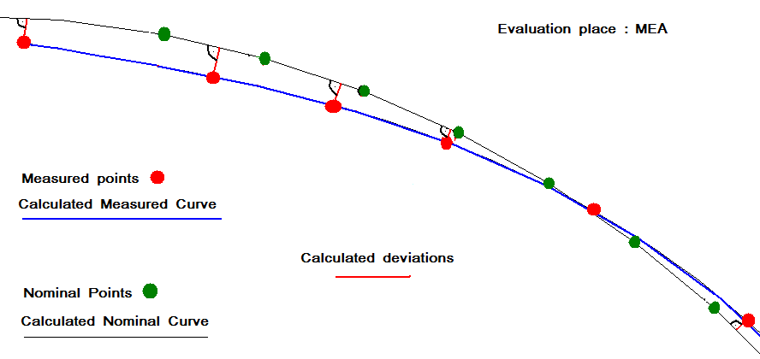  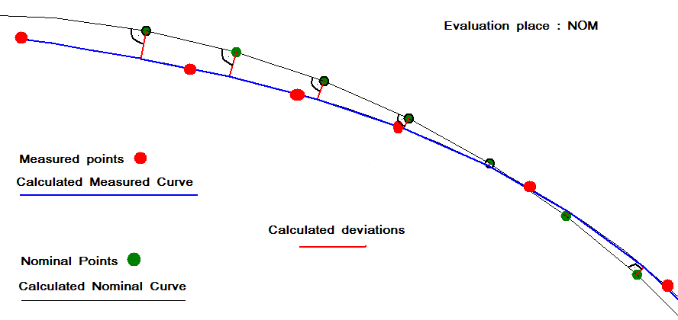 | 1 or 2 | 1
EvaluationDirection | Defines the evaluation directions (to which curve is perpendicular the deviation). The possible inputs are 1 or 2, which is first or second curve as given in 2dinp.dat | 1 or 2 | 1

Table showing the relations between the parameters EvaluationPlace and EvaluationDirection to the output data in 2dout.dat.

Parameters |  | Output data in 2dout.dat
EvaPlace | EvaDir | Points from | Direction from  (Deviations calculated along the normal of)
1 | 1 | Curve 1 | Curve 1
1 | 2 | Curve 1 | Curve 2
2 | 1 | Curve 2 | Curve 1
2 | 2 | Curve 2 | Curve 2

3.5 Function 5 – Display/print curves

This options displays the curves and if present also the deviations. It supports also a simple print out.

Function=5
Parameter | Description | Allowed values | Default
Closed | Type of the curve (opened / closed) | Y or N | N
Plane | Workplane | XY,YZ or ZX | XY
Scale | Scale factor for the curve | Double | Mandatory
Magnification | parameter used to specify the direction of the radius correction with the normal vectors It is only for not closed curves | Double | Mandatory

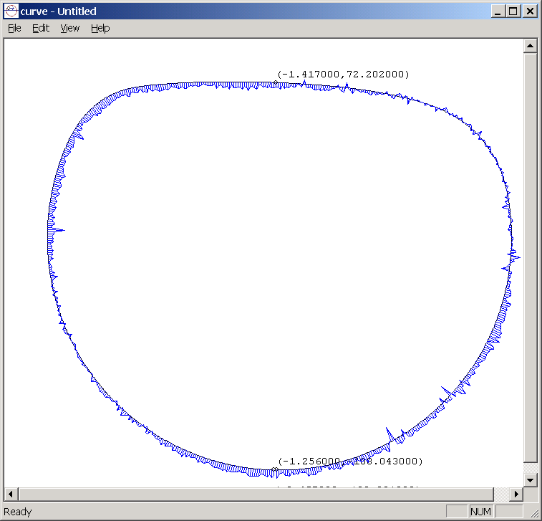

3.6 Function 6 – 2D best-fit
This function performs 2D best-fit between 2 curves, best-fitting the points of the first curve to the second curve. You must pass in 2dinp.dat 2 curves! In 2dout.dat:
- If method=curve: you will find the best-fitted curve and additional record with the best-fit offsets and rotation. The points in the 2dout.dat are compared to the first curve according to the parameters “EvaluationPlace” and “EvaluationDirection” (for more details about this parameters look at Function 4)
- If method=points you will find the best-fitted points and additional record with the best-fit offsets and rotation. 2dout.dat contains the new position of the second “point set”, The Deviations are compiled with the distance found from each point of the new position of the second “point set” to the corresponding point of the first “point set”. The vectors must be from the new position of the point to its nominal point. (Evaluation Place and Evaluation direction have no effect if the method is “points”)

Function=6
Parameter | Description | Allowed values | Default
result | Name of the result element | Any String | INPUTNAME
Closed | Type of the curve (opened / closed) | Y or N | N
Plane | Workplane | XY,YZ or ZX | XY
External | The meaning is how the measurement is performed, external or internal to the detail. | Y or N | Y
Material | parameter used to specify the direction of the radius correction with the normal vectors It is only for not closed curves | L or R | L
Note: This last 2 parameters are important for definition of the deviation sign! (as long as at the end of the best-fit a comparison takes place!)
Xshift | Fix X | Y or N | N
Yshift | Fix Y | Y or N | N
Rotation | Fix Rotation | Y or N | N
Minimize | Special algorithm | Y or N | N
EvaluationPlace | optional parameter for the evaluation place for the comparison (see Function 4) |  | 1
EvaluationDirection | optional parameter for the evaluation direction for the comparison (see Function 4) (may be 1 or 2) |  | 2
Method | If “Curve” the algorithm calculates the best-fit to the sum of squares of the deviations of every measured point to the nominal curve  If “Point” the algorithm calculates the best-fit to the sum of squares of the deviations “point-to-point”. In this case the nominal and measured curve MUST have the same number of points, and MUST have the correct order (the user must guarantee that!). | Curve  Points | Curve

#new element for output after the first element in the same output file
#$ELE (NAM=B$FIT, TYP=ELE, FLD=X) -- begin row
#0.237 -- X shift in MM
#-0.046 -- Y shift in MM
#5.5 -- Rotation in degrees
#$END

When finished it creates the file:
2dend.dat
#OK
#date - time

Note: currently this function may need some time for the calculation (upon the amount of point data).

3.7 Function 7 – Intersection with line

Finds the intersection point(s) between a curve and line. 2dout.dat will contain the list of intersection point(s).

function=7

#optional, if not exist - result=INPUTNAME
result=ELENAME

# Y or N , is the curve closed, optional , default N
closed=Y

#plane can be XY, YZ, ZX
plane=XY

#coordinates of a one point from the line, taken into consideration only the coordinates from the plane parameter

xline=5.0
yline=5.0
zline=1.0

#angle between line ant plane in radians

angle=0.785

Output in 2dout.dat: list of the intersection points

3.8 Function 8 – Intersection with circle

Finds the intersection point(s) between a curve and circle. 2dout.dat will contain the list of intersection point(s).

function=8

#optional, if not exist - result=INPUTNAME
result=ELENAME

# Y or N , is the curve closed, optional , default N
closed=Y

#plane can be XY, YZ, ZX
plane=XY

#coordinates of the center of the circle, taken into consideration only the coordinates from the plane parameter

xcircle=5.0
ycircle=5.0
zcircle=1.0

#diameter of the circle

diameter=100

Output in 2dout.dat: list of the intersection points

3.9 * Function 9 – Middle Curve

Finds the middle curve between 2 curves (contained in 2dinp.dat). 2dout.dat will contain the middle curve. (middle curve is defined as sequence of points lying on the centers of circles that are tangent to both initial curves)

function=9

#optional, if not exist - result=INPUTNAME
result=ELENAME

# Y or N , is the curve closed, optional , default N
closed=Y

#plane can be XY, YZ, ZX
plane=XY

Output in 2dout.dat: middle curve

3.10 Function 10 – Circle centering

Finds the contact points and the center point of a circle “centered” in a gap formed by a curve. (given by 2dinp.dat).

function=10

#optional, if not exist - result=INPUTNAME
result=ELENAME

#plane can be XY, YZ, ZX
plane=XY

#coordinates of a one point from where the centering starts

xstart=5.0
ystart=5.0
zstart=1.0
diameter=10

#angle of centering

angle=0.785

#centertype – how the circle touches the curve. 0 – on the points(default), 1 – on the spline
centertype = 0

Output in 2dout.dat: list of 3 points (2 contact points and the center point) – X,Y,Z contain the coordinates, the both contact points have also the normal direction to the curve.

3.11 Function 11 – Line fit

Fits the given point sequence to line. Calculates the deviations for each point to this line.

function=11

#optional, if not exist - result=INPUTNAME
result=ELENAME

#plane can be XY, YZ, ZX
plane=XY

#material side (L or R) – used to calculate vectors and deviations sign (default R)
material=L

Note: Vectors are orthogonal to the line calculated and if material=L, the vectors have directions to R (and vice versa):
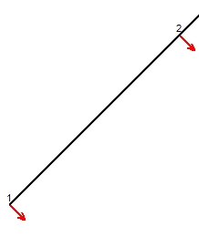

The sign of the deviations is calculated using the following rule: respect to the line calculated, if the point deviates in its vectors direction, then the deviation has sign “+”. If the point deviates in the opposite direction respect to the vector, the deviation has sign “-“

Output in 2dout.dat: 2 elements

The First element has the same number of points as 2dinp.dat, but in filed “a” there is a calculated deviation for that point to the fitted line. The vectors and deviations are calculated as described above.

The second element has 1 point where:
X,Y,Z is the coordinate of the gravity point of all input points, projected on the fitted line.
U,V,W are the direction of the calculated line.

3.12 Function 12 – Circle fit

Fits the given point sequence to a circle. Calculates the deviations for each point to this circle.

function=12

#optional, if not exist - result=INPUTNAME
result=ELENAME

#plane can be XY, YZ, ZX
plane=XY

#algorithm – the algorithm used to fit the circle, can be Gauss (min squares), Inscribed, Outscribed. (default – Gauss)

algorithm=Gauss

#In/out (internal or internal circle) – used to calculate the vectors directions and deviations sign (default N)
external=N

Note: Vectors are orthogonal to the circle circumference calculated and if external=N, the vectors have directions to the center of the circle:
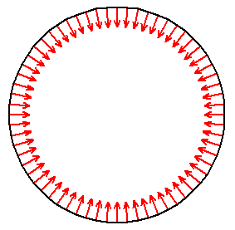

The sign of the deviations is calculated using the following rule: respect to the circle calculated, if the point deviates in its vectors direction, then the deviation has sign “+”. If the point deviates in the opposite direction respect to the vector, the deviation has sign “-“

#iteration_conditions, meaned as parameters to be kept fixed during the calculation (default missing, which means, the fit is free). These parameters have sense only for Gauss algorithm
xcenter=5.0
ycenter=5.0
zcenter=5.0
radius=1.0

Output in 2dout.dat: 2 elements

The First element has the same points as 2dinp.dat, but in filed “A” there is a calculated deviation for that point to the fitted circle. The vectors and deviations are calculated as described above.

The second element has 1 point, where:
X,Y,Z is the coordinate of the fitted circle, A is the radius

3.13 Function 13 – Filter Fourier

Performs a filter operation on “A” column of the given point sequence (filtering the deviations).

function=13

#optional, if not exist - result=INPUTNAME
result=ELENAME

# Y or N , is the curve closed, optional , default N
closed=Y

#plane can be XY, YZ, ZX
plane=XY

#Can be “polar” or “linear”
filter=polar

#Can be “low_pass”, “high_pass “or “band”
filter_type=low_pass

#filter_factor – expressed in mm for the linear filter or in Hz for the polar filter (for the band filter 2 values must be present, separated by “,”)
filter_factor=50

Output in 2dout.dat: filtered element

3.14 Function 14 – Intersection betw. 2 curves

Finds the intersection point(s) between a curve and curve. 2dout.dat will contain the list of intersection point(s). 2dinp.dat contains the two curves

function=14

#optional, if not exist - result=INPUTNAME
result=ELENAME

# Y or N , is the curve closed, optional , default N
closed1=Y
closed2=Y

#plane can be XY, YZ, ZX
plane=XY

Output in 2dout.dat: list of the intersection points

3.15 Function 15 – Perimeter, square

Finds the perimeter and the sq. of a curve. 2dout.dat will contain the one line only with firs value the length, the second the sq.. 2dinp.dat contains the curve.

function=15

#optional, if not exist - result=INPUTNAME
result=ELENAME

# Y or N , is the curve closed, optional , default N
closed=Y

#plane can be XY, YZ, ZX
plane=XY

Output in 2dout.dat: one point with first value the perimeter, the second, the square (calculated always as for closed!).

3.16* Function 16 – Automatic Curve splitting function

This function will create series of best-fitted circles or lines from a point sequence upon some criteria. (The best-fitted circles are Gaussian ones). 2dinp.dat contains the point data (source). 2dout contains series of point data together with the geometrical information similar to what is defined in Function 11 and 12. The name of the elements that can be only Lines or Circles are LINExx or CIRCLExx / LINE$FITxx or CIRCLE$FITxx where xx is the index of the element.

2dpar.dat defines the parameters of the fitting algorithm:

# Type of the algorithm (currently only 1)
Algorithm=1

# Maximum permitted form error of each calculated element – no one of the calculated elements may have form error above this value!
MaxFormError=0.01

# Maximum permitted Circle radius – no one of the circles calculated may have radius greater than the value indicated in this parameter
MaxCircleRadius=200

Notes:

Example of 2dinp.dat:
$ELE (NAM=LIN_1_CRV,TYP=APT, FLD=(X,Y,Z))
100.64188, 169.36323, -305.00368, 0.00000, 0.00000, 0.00000, 1.00000, 0.00000, 0.00000
100.84131, 169.41044, -305.00397, 0.00000, 0.00000, 0.00000, 1.00000, 0.00000, 0.00000
120.46391, 168.18767, -305.00247, 0.00000, 0.00000, 0.00000, 1.00000, 0.00000, 0.00000
…
$END

Example of 2dout.dat (the example shows onlu the first and second segment found):

$ELE (NAM=LINE1, TYP=APT, FLD=(X,Y,Z))
100.641880,169.363230,-305.003680,0.000000,-0.078786,-0.996892,1.000000,0.551364,0.000000
100.841310,169.410440,-305.003970,0.000000,-0.078786,-0.996892,1.000000,0.488588,0.000000
101.034590,169.454330,-305.003930,0.000000,-0.078786,-0.996892,1.000000,0.429607,0.000000
…
$END

$ELE (NAM=LINE$FIT1, TYP=ACT, FLD=(X,Y,Z,U,V,W))
110.729400,172.128429,0.000000,0.000000,0.996892,-0.078786,0.000000,0.000000,0.000000
$END

$ELE (NAM=CIRCLE1, TYP=APT, FLD=(X,Y,Z))
103.992720,170.059430,-305.003770,0.000000,-0.421783,0.906697,1.000000,-0.000389,0.000000
104.182600,170.166250,-305.004340,0.000000,-0.547781,0.836622,1.000000,0.000677,0.000000
104.353700,170.295370,-305.003890,0.000000,-0.660652,0.750692,1.000000,-0.000232,0.000000
104.504980,170.449830,-305.003250,0.000000,-0.761014,0.648735,1.000000,0.000313,0.000000
104.633980,170.623770,-305.003720,0.000000,-0.845917,0.533315,1.000000,-0.000535,0.000000
104.736010,170.815940,-305.003430,0.000000,-0.913722,0.406340,1.000000,-0.000014,0.000000
104.809090,171.018510,-305.003150,0.000000,-0.962202,0.272335,1.000000,0.000181,0.000000
$END

$ELE (NAM=CIRCLE$FIT1, TYP=ACT, FLD=(X,Y,Z,R))
103.355138,171.430027,0.000000,0.000000,0.000000,0.000000,0.000000,1.511248,0.000000
$END

….

3.17 Function 17 – Shift Points to given radial position along given profile

This function shifts point (or points) along a given profile in order to get a point on the same profile at given radius.
Explanation on the operations executed by this function (the example refers to a single point only, but if many ponts are given, the same operation will be applied to all those points, keeping in the output the Z coordinate of those points):

1. Suppose we have a point in XY plane and a profile in this plane (2dinp.dat): | 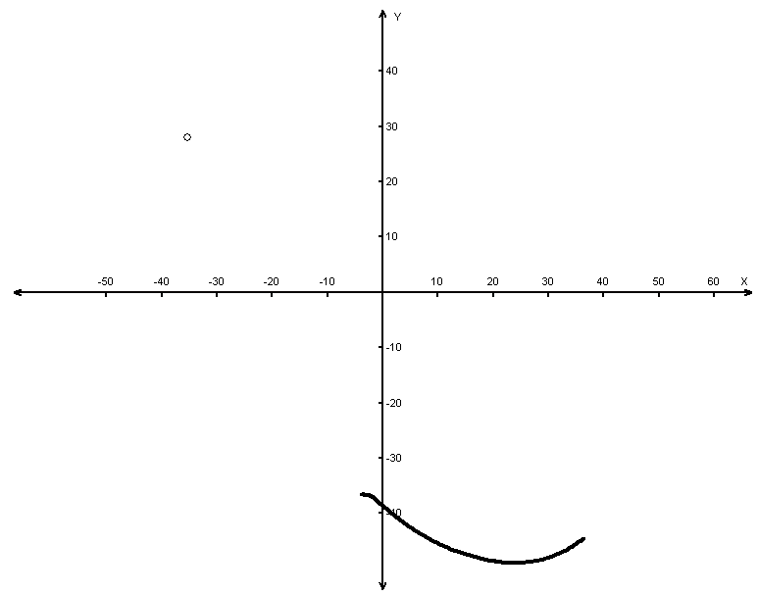
We have also a given diameter (2dpar.dat): | 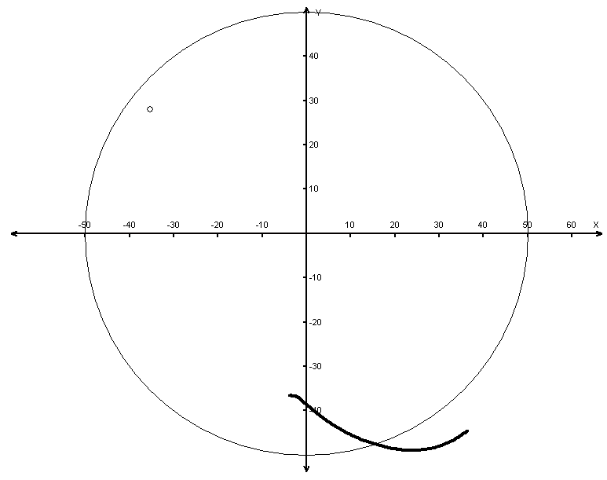
The first step is to “attach” the profile (rotating it arround z) in order that it comes over a point. (this is like constructing a circle with radius equal to the radius of the single point; intersection the diameter with the curve, obtaining a point; finding the angular difference between the original point and the point found by the intersection; rotating the profile at this angle). So we will have something like this: | 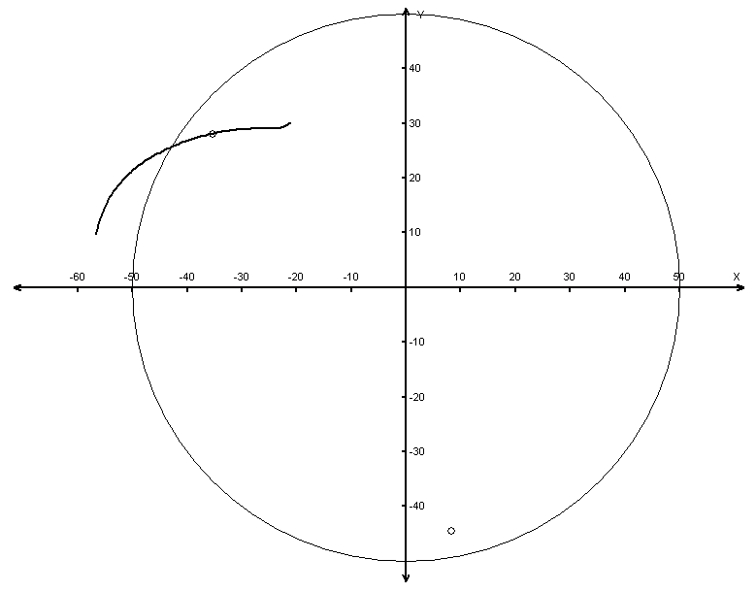
The second step is to get the intersection point between the circle and the rotated profile (just an intersection of the profile with the circle having the given diameter). This point will be the result point of the calculation.  If there are more than 1 point to be corrected, the function may also execute ordering of the corrected data along Z. | 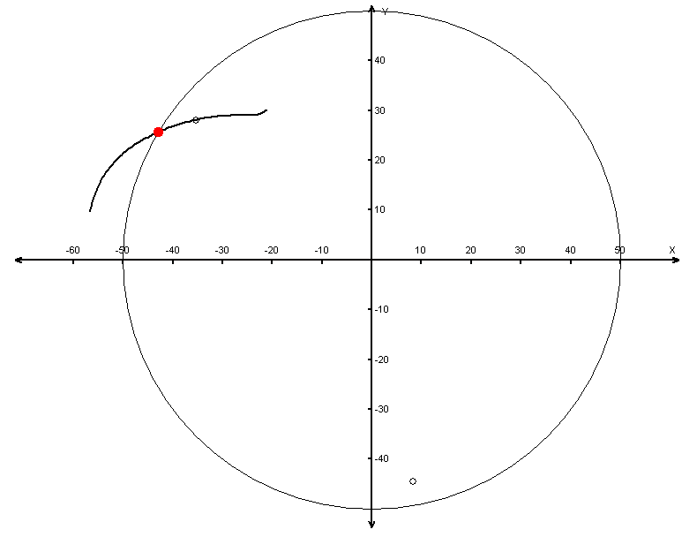

2dinp.dat will contain 2 elements: 1st one with the nominal profile data, 2nd one with the data to be converted (may be composed by one or more points)
2dpar.dat will have the followng parameters:

Function=17
Parameter | Description | Allowed values | Default
Diameter | Value of the theoretical diameter for shifted points | Double | None
SortZ | Sorting the corrected data on Z (may be aplied only if the 2nd element in 2dinp.dat contains more than 1 point) | N – Do not sort; I – Sort on increase Z; D – Sort on decrease Z | N

2dout.dat contains the data of the calculation (the number of points will be equal to the points passed as second element in 2dinp.dat.)

4. Reporting problems and suggestions

Please report problems and suggestions via e-mail. ( support@group-numerics.com )

Please attach the log.log file found in curve.exe directory.

5. Licensing

The program curve.exe auto starts one month trial period on first use. The program will be fully functional for 31 days. The purpose of this time period is that the user can test all functionality of the program and decide to purchase it.

When initial trial expires the curve.exe program will not perform the functions. Instead license message will be displayed each time the program is started:

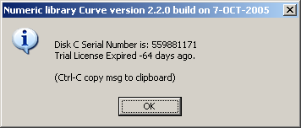

If you like to purchase a permanent license or extend a trial license you may copy this text with Ctrl-C and send it in an email. The disk serial number will be needed to create a permanent or extended license.

The permanent license will be sent as file named License.cfg. This file only has to be saved in the same directory with the curve.exe program.

The license information can be tested at any time with command line option:

curve.exe –L

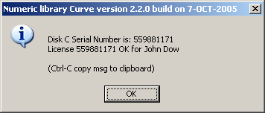

License information is also logged in the log file Log.log in the curve.exe directory.

